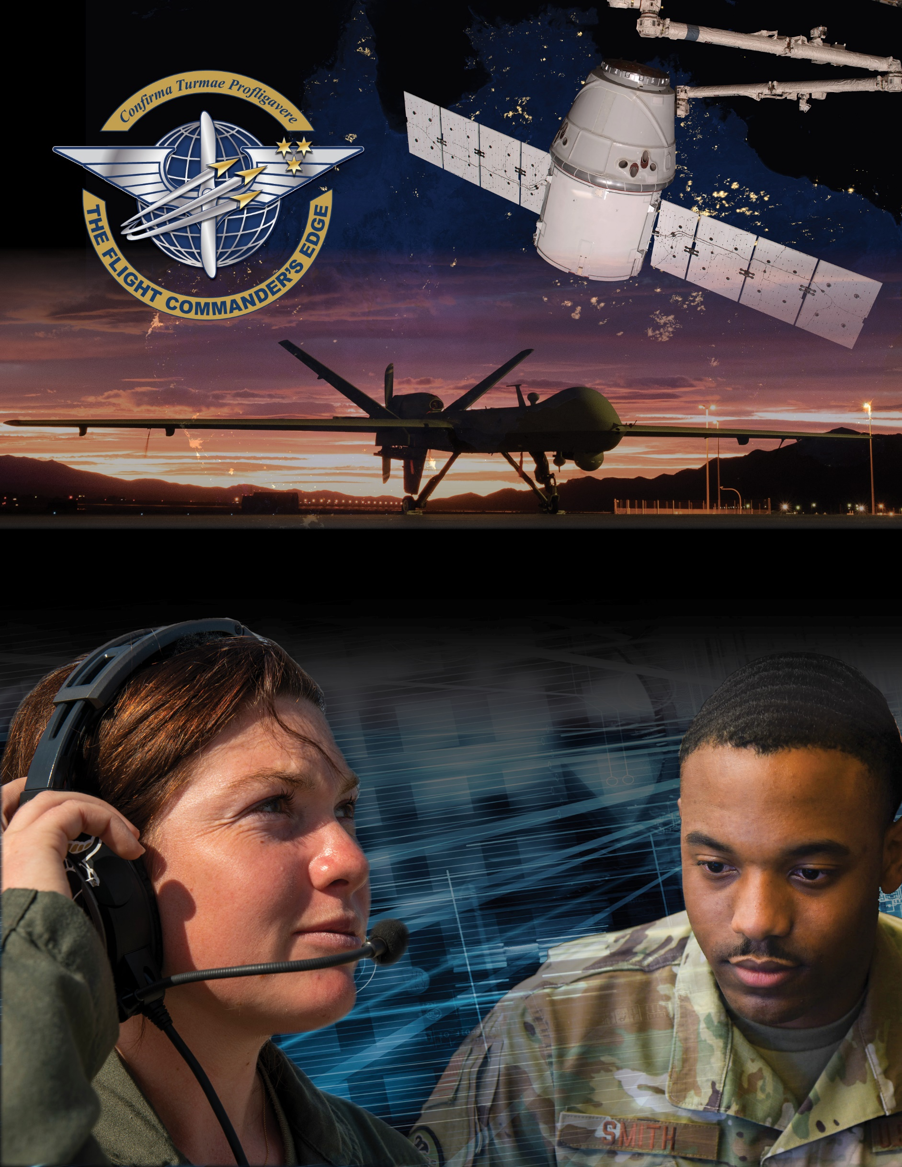

**Lesson Plan**



**Conflict Management**

***8 April 2025***

Table of Contents

About the Lesson 3

Before the Lesson 4

Presenting the Lesson 5

Appendix: Required Materials and Handouts 12

**How to Use this Lesson Plan**

This lesson plan is divided into three key sections and an appendix containing supporting material.

The **About the Lesson** section outlines the lesson and identifies requirements for its effective use. Course Directors should use this section to (a) understand the purpose and context of the lesson, (b) learn about lesson pre-requisites, and (c) guide the selection of facilitators.

The **Before the Lesson** section provides details on the preparation required for this lesson, including participant prerequisites (if any), recommended facilitator pre-course readings, and guidance on how to prepare the classroom.

The **Presenting the Lesson** section contains the actual lesson plan. It provides the recommended outline, discussion, and slide prompts along with actual *questions* and *recommended language* for the facilitator to use in the classroom.

The **Appendix** includes any required in-class handouts or exercise material.

For more information on how lessons are structured, or how to use them in the course, see the ***Course Director’s Handbook*** or ***Facilitator’s Resources.***

**Contact Us**

Email: [flightcommandersedge@us.af.mil](mailto:flightcommandersedge@us.af.mil)

Website: <https://www.airuniversity.af.edu/GCPME/Flight-Commanders-Edge/>

# About the Lesson

**Conflict Management**

## Overview

Flight commanders face conflict. It is the nature of the business. Research shows that first-line supervisors and middle-level managers can spend up to 25 percent of their time dealing with conflict. Most conflicts are either people-focused or issue-focused. This lesson explores basic sources of conflict and provides insight to five recognized conflict management styles. In addition to encouraging conversations on effective approaches to managing conflict, participants will see how if managed properly, not all conflict is bad.

## Objectives

By the end of this lesson, participants will be able to:

1. Identify the two types of conflict common at the flight level.
2. Identify conflict management styles.
3. Recognize effective, and ineffective, approaches to conflict management styles.

## Recommended Prerequisites

* None

## Recommended Time

* 50 minutes

## Recommended Facilitator Qualifications

This lesson is designed for a facilitator with the following minimum qualifications:

1. Subject matter knowledge
2. Command-level experience

Subject matter knowledge can be developed using the information presented in **Preparing the Facilitator** section of this document.

# Before the Lesson

## Preparing the Participant

* None. There is no pre-work for this lesson.

## Preparing the Facilitator

All required materials and participant preparation, plus:

* Massachusetts Institute of Technology. “The Five Conflict Styles” *The Collaboration Toolbox, Module 1, Conflict Management.* No date.
  + Available at <http://web.mit.edu/collaboration/mainsite/modules/module1/1.11.5.html>

Note: This article is provided for information only. Use within this program does not constitute endorsement of the vendor nor its products by Air University.

(Optional) Additional deep-dive preparation materials are available on *The Flight Commander’s Edge* website.

## Preparing the Classroom

Ensure the classroom provides/is provisioned with:

* Adequate classroom space for separate small group discussions.
* Computer and projector with internet connectivity (internet connectivity not required).

The appendix includes a “Group Labels” sheet for *Preferred Conflict Management Style Groups*. Facilitators need either five copies (use a highlighter to indicate group name), or one copy to cut into strips.

## Preparing Required Materials

Prepare one copy of each handout below for each participant. Do not distribute handouts before the class.

* Global College of PME, *Conflict Management Style Survey*
* Global College of PME, *Conflict Management Style Scoresheet*
* Global College of PME, *Conflict Management Self-Assessment Worksheet*

Handouts are available in the Appendix.

# Presenting the Lesson

***NOTE:*** *This lesson is designed for up to five (5) groups of participants. Groups should be no larger than five (5) members to maximize participation during small group discussion.*

## Introduction (5 minutes)

The introduction to the lesson sets the stage for future learning through class discussion on previous experiences with conflict, or anticipated conflicts as a flight commander.

### Slide 1: Conflict Management

Introduce the lesson.

**One of the more challenging things you will face as a flight commander is managing the conflict you will inevitably experience.**

**This lesson is designed to arm you with some information on the nature and environment of conflict and will allow you to identify your conflict management style. In addition, the class will have the opportunity to recognize both effective, and ineffective approaches to managing conflicts.**

### Slide 2: Objectives

This slide lists the lesson objectives.

After participants have reviewed the lesson objectives, continue.

## Initial Discussion (5 minutes)

The initial discussion begins with the class voicing their experiences, and their understanding of the nature of conflict. This lesson centers on separating the topic into two areas: people and issues. The discussion ends with the participants self-discovering their conflict examples being sorted into those two categories.

**Slide 3: Class Discussion**

**Let’s share, as a class, your experiences regarding these two questions:**

**What kinds of conflict have you experienced at work?**

**As a flight commander, what kinds of conflict do you anticipate in the future?**

**Anticipated Responses:** Answers will vary. Rather, guide the conversation toward the types of conflict that a flight commander would experience. In general, responses should fall into two generalized categories:

* People
* Issues

As you listen, divide the comments into two categories, *people* and i*ssues*.

Record *people* and *issues* responses on the board.

**Important Note:** Avoid labeling conflict as “good” or “bad. As good can often be derived from conflict.

After the class discussion is complete, continue.

### Slide 4: Large Group Discussion

Summarize the discussion by illustrating two key points:

**The conversation is leading us to the conclusion that often conflict is driven by relationships between people.**

**However, conflict can also result from miscommunication about an issue.**

**Sorting all conflict into two categories may an oversimplification, but it does provide you an easy-to-remember framework for understanding the types of conflict you will experience as a flight commander.**

**By understanding the types of conflict you will experience, we can begin to develop strategies to manage it. How you handle “conflict” is called your Conflict Management Style.**

## Student Survey (10 minutes)

Divide the participants in small groups (4 or 5 members). They will complete a survey independently and then in their small group review and discuss their impressions of the (unofficial) survey. Once in small groups prompt the participants with the following information.

### Slide 5: Survey

**Let’s take a quick survey to learn your Conflict Management Style.**

**You will have ten (10) minutes to complete this independently. You will have an opportunity to discuss in your small group later in the lesson.**

Distribute **Global College of PME, *Conflict Management Style Survey*** to all participants. This worksheet should be completed independently. It will be self-scored later in the lesson.

Monitor participants’ activity.

After ten (10) minutes, or when all participants have finished the survey, continue.

## Content Presentation (5 minutes)

Introduce the five conflict management styles to prepare the group for the survey scoring.

### Slide 6: Conflict Management Styles

**The short survey you just completed will help you identify your predominant Conflict Management Style.**

**In general, there are five different ways people handle conflict. They are shown here.**

Show slide and prompt the small groups to briefly discuss.

|  |  |  |  |  |
| --- | --- | --- | --- | --- |
| **Competing** | **Avoiding** | **Accommodating** | **Collaborating** | **Compromising** |
| Reflects a desire to achieve one’s own ends at the expense of someone else. Also known as “win-lose”. | This involves indifference to the concerns of both parties. It reflects a withdrawal from or neglect of any party’s interests. | Reflects a mirror image of competition, entirely giving in to someone else’s concerns without making any effort to achieve one’s own ends. A tactic of appeasement. | Reflects an effort to fully satisfy both parties. This is a problem-solving approach that requires the integration of each party’s concerns. | Reflects a sharing approach where both parties give up something, yet both parties get something. Both parties are moderately, but not completely, satisfied. |

Introduce the skills and associated behaviors by stating the following:

**These behaviors are generally the most visible ones for a particular Conflict Management Style. Take a moment and consider how you handle conflict today, and, before we score your results, remember that none of us can be characterized as having a single, one-size-fits-all style when managing conflict.**

**In your groups briefly discuss**

**What do these terms mean?**

**Is one of these styles best for dealing with people issues? Why?**

**Is one of these better for managing issues issues?**

Address any confusion on the categories before continuing.

After five (5) minutes, continue.

## Application Activity (20 minutes)

In the application activity, participants score their survey and then discuss their conflict management style within their small group. After scoring they will separate based on their results to discuss effective approaches to using the conflict management styles, then share their findings with the other groups.

### Slide 7: Survey Scoring

Distribute **Global College of PME, *Conflict Management Style Scoresheet*** to all participants. This worksheet will be completed independently.

**Before we move into the use of conflict management styles, it is time to score your survey.**

**Take a few minutes and tally your results on this worksheet. Once everyone in your small group has scored their survey feel free to discuss:**

**Which is your identified *preferred* Conflict Management Style?**

**Do you agree with it?**

After ten (10) minutes, or when participants have finished scoring/discussing continue.

While the participants are scoring and discussing, prepare the classroom by labelling the group areas (printed labels are in the appendix): Competing, Collaborating, Compromising, Avoiding, Accommodating. Participants will rearrange themselves into groups based on their results (the total with the **lowest** score is their *preferred* Conflict Management Style).

After the room is prepared, continue.

### Slide 8: Effective Approaches to Conflict Management Styles

Introduce the exercise.

**Typically, after getting the results of any survey, the first question people ask is: "What are the right answers?" In the case of conflict management styles, there really aren’t universal “correct” answers. Depending on the situation all five styles are useful.**

**Now that you have an idea of your conflict management style, it is time to do a quick activity.**

**Go ahead and separate into groups based on your results: Competing, Collaborating, Compromising, Avoiding, Accommodating. Determine your group based on your survey total area with the lowest score.**

Allow a moment for participants to settle into their new groups. You may not have participants in every group at this point.

Begin the exercise with the following directions.

**It would be possible to teach a lengthy course on conflict management, but we don’t have that kind of time. What we do have time for is helping each other out. That is what we are going to do now through this activity.**

**Now that we’ve reviewed the nature of conflict, and identified conflict management styles it is time to ask:**

**How do you get better at managing conflict using the**

**Conflict Management Styles?**

**In your small groups, take five (5) minutes to brainstorm**

**When is the BEST time, or situation, to use this particular style?**

**Also consider when it is NOT a good time to employ this style.**

**At the end of your discussion, be prepared to share your group’s suggestions.**

Begin the exercise and monitor for time. Do not let the groups go longer than five (5) minutes to allow enough time for the large group outbrief.

After five (5) minutes, continue.

### Slide 9: Large Group Outbrief

Reconvene the large group; ask one member from each group to share their group’s tips.

**What did your small group decide regarding the BEST time to use this style?**

**Is there a time, or situation when this style is NOT appropriate to use?**

Ask clarification questions of the groups if required. Remind participants to record tips and ideas they may want to explore or apply in the future on the back of scoresheet handout.

**Anticipated Responses:**

|  |  |  |  |  |
| --- | --- | --- | --- | --- |
| **Competing** | **Avoiding** | **Accommodating** | **Collaborating** | **Compromising** |
| **Use When:**  - Need quick  Actions (i.e., emergencies)  - When you  know you  are “right”  **Don’t Use**  **-** If you do not  have power  to make final  decision | **Use when:**  - Gathering  more info  outweighs  advantage  of quick  decision  **Don’t Use**  - To avoid  making a  decision | **Use when:**  - You find you are  wrong or less  experienced  - The issue is more  important to  others  **Don’t Use**  - Too much or too  Often  - Can deprive you  of influence | **Use when:**  - Issue is too  important to  compromise  - Objective is to  learn or  understand  other views **Don’t Use**  - Unless you  have time | **Use when:**  - Under time  pressure  - Temporary  settlement to  complex issue **Don’t Use**  - In a power  struggle or in  show of  ‘gamesmanship’ |

## Lesson Wrap-Up (5 minutes)

The final lesson activity is a self-assessment of conflict management behaviors. This activity feeds the final lesson in the course – *The Road Ahead* – and will be used to support the development of the students’ personal development plan.

Distribute the **Global College of PME, *Conflict Management Self-Assessment Worksheet*** to all participants.

When complete, continue.

### Slide 10: Self-Assessment Exercise

Initiate the self-assessment and wrap up the lesson.

**Recognizing the different aspects of a conflict allows you to deal with situations more effectively. But a reminder that not all conflict is bad. Your approach to this as a flight commander is an important part of your role in the squadron. Conflict management is the ability to identify and navigate conflicts in a way that is efficient, effective, and fair; hallmarks of a good flight commander.**

**Now that you have had the opportunity to take a short survey on your conflict management style and even crowd-sourced ways to improve using those styles, it’s time to take the next step and complete a self-assessment.**

**The *Conflict Management Self-Assessment Worksheet* is designed to help you plan for your future. The instructions are self-explanatory. Take a moment to read them, then fill out the sheet. If you need more time, you can go into the break.**

**Keep this worksheet for reference. You will need it again for the last lesson of the course.**

End. Break (10 minutes).

# Appendix: Required Materials and Handouts

The materials required for this lesson include:

* Global College of PME, *Conflict Management Style Survey*
* Global College of PME, *Conflict Management Style Scoresheet*
* Global College of PME, *Conflict Management Self-Assessment Worksheet*

These handouts, on the following pages, are designed for printing directly from the lesson plan. Ensure you print enough copies for all class participants.

The appendix includes a “Group Labels” sheet for *Preferred Conflict Management Style Groups*. Facilitators need either five copies (use a highlighter to indicate group name), or one copy to cut into strips.

The appendix also includes a **To learn More** handout which you may distribute at the end of the lesson as a student resource:

* Global College of PME, *United States Negotiation Center Information Sheet*

**Conflict Management Style Survey**

*Developed by the Global College of PME*

Below are three situations. **Rank** the alternative actions from 1 to 5 with

1 – The first approach you would use (**1: most desirable**) to

5 – The last approach you would use (**5: least desirable**)

For this simple survey there is no one best answer.

1. You are the general manager of a manufacturing plant. The purchasing department has found a source of material at a lower cost than the one being used. However, the production manager says the current material is superior, and she doesn’t want to change. The quality control manager says that both will pass inspection with similar results. You would:

|  |  |  |
| --- | --- | --- |
| **Rank order**  **1 – 5** | | |
|  | A. | Decide who is right and make the other comply. |
|  | B. | Do nothing: let the purchasing and production managers work it out between themselves. |
|  | C. | Suggest having the purchasing manager find an alternative material that is cheaper, but acceptable to the production manager. |
|  | D. | Get the purchasing and production managers together and work out an agreement acceptable to both parties. |
|  | E. | Have the purchasing and production managers’ compromise. |

2. You are a college professor in the business school at a well-respected college. You have started a consulting track to help out the local community and local businesses and have the title of director of consulting services, which your Dean personally approved. You run the consulting services through the business education department, using yourself and other faculty as pro-bono consultants. It has been going well. Randy, the director of continuing education says that these consulting services should come under his department and not be a separate department. You would:

|  |  |  |
| --- | --- | --- |
| **Rank order**  **1 – 5** | | |
|  | A. | Do what you can to stop the move: you go to the dean and request that the consulting services stay under your direction in the business school, as the dean OK’d originally. |
|  | B. | Do nothing. The dean will surely see through this “power grab” and turn Randy down. |
|  | C. | Go along with Randy’s request. It’s not worth fighting about: you can still consult. |
|  | D. | Go talk to Randy. Try to come up with an agreement you are both satisfied with. |
|  | E. | Suggest that some services be under continuing education, but that others, like your consulting, remain with you in the business department. |

3. You are a branch manager for a bank. While speaking to your employees, one of your colleagues interrupted you twice and didn’t allow you to finish your thoughts to the group. It is not the first time, and this behavior actually happens during most meetings. The meeting just ended. You would:

|  |  |  |
| --- | --- | --- |
| **Rank order**  **1 – 5** | | |
|  | A. | Forcefully tell the colleague that you put up with being cut off but will not tolerate it in the future. |
|  | B. | Do nothing: it’s no big deal. |
|  | C. | Don’t say anything because it might hurt your relationship, even if you’re a little upset about it. |
|  | D. | Discuss it in a friendly manner but try to get the colleague to stop this behavior. |
|  | E. | Tell the colleague that you will listen without interrupting if he or she does the same for you. |

*Once done wait for the facilitator to give further instructions.*

**Conflict Management Style Scoresheet**

*Developed by the Global College of PME*

Now that you have read the three situations and ranked all five of the alternative actions from 1 to 5, consolidate your scores below:

|  |  |  |  |  |
| --- | --- | --- | --- | --- |
| **To determine your preferred conflict management style, place your ranking numbers 1-5 on the lines below. Then total the row and write the number below.** | | | | |
|  | **Situation 1** | **Situation 2** | **Situation 3** | **Row total** |
| **A.** |  |  |  |  |
| **B.** |  |  |  |  |
| **C.** |  |  |  |  |
| **D.** |  |  |  |  |
| **E.** |  |  |  |  |

The total with the **lowest score** is your *preferred* conflict management style. The more even the totals are, the more flexible you are at changing conflict management styles. Very high and very low totals indicate less flexibility.

Remember there is no one best conflict style in all situations. The best conflict management style depends on the situation you find yourself in. See below for the simple definitions of the “Five Approaches to Conflict Management”; you can write your corresponding scores in:

|  |  |  |  |  |
| --- | --- | --- | --- | --- |
| **Competing** | **Avoiding** | **Accommodating** | **Collaborating** | **Compromising** |
| **Row “A”** | **Row “B”** | **Row “C”** | **Row “D”** | **Row “E”** |
|  |  |  |  |  |
| Reflects a desire to achieve one’s own ends at the expense of someone else. Also known as “win-lose”. | This involves indifference to the concerns of both parties. It reflects a withdrawal from or neglect of any party’s interests. | Reflects a mirror image of competition, entirely giving in to someone else’s concerns without making any effort to achieve one’s own ends. A tactic of appeasement. | Reflects an effort to fully satisfy both parties. This is a problem-solving approach that requires the integration of each party’s concerns. | Reflects a sharing approach where both parties give up something, yet both parties get something. Both parties are moderately, but not completely, satisfied. |

*This is an unofficial survey based on the Thomas-Killam Conflict Mode Instrument. This is for use during a basic conflict management lesson. It is not intended to predict behaviors during actual conflict management situations but is used as a springboard into the topic of conflict management styles. Not designed for distribution or use outside of this lesson.*

**Group Labels**

Group

Preferred Style: **Competing**

Group

Preferred Style: **Collaborating**

Group

Preferred Style: **Compromising**

Group

Preferred Style: **Avoiding**

Group

Preferred Style: **Accommodating**

## Self-Assessment Worksheet

This self-assessment provides an opportunity for you to assess your own leadership skills and behaviors. These skills and behaviors are based upon the concepts addressed within this lesson. *You will use these worksheets again during the final lesson of the course.*

**NOTE:** Not all of these skills and behaviors were covered in this lesson, rather, they reflect what an ideal flight commander should know and be able to do in this topic area.

Rate yourself on a scale of 1-5 in each of the areas below:

5 – Needs No Improvement 3 – Average 1 – Needs Significant Improvement

|  |  |  |  |
| --- | --- | --- | --- |
| Competency | Skill | Behavior | Self-Assessment  (1-5) |
| Fostering Collaborative Relationships | Builds Teams and Coalitions | At the team or flight level:   * Assess environment to understand nature of team conflict * Foster cooperation among team members * Demonstrate trustworthiness * Develop alliances through collaboration and consensual decisions * Allow subordinates to develop by learning from mistakes * Recognize conflict can be “people issue” or an “*issue* issue” * _______________________ * _______________________ |  |
| Fostering Collaborative Relationships | Negotiating | At the team or flight level:   * Decide on conflict management style - depending on situation * Encourage proper dissent as a function of conflict management * Model understanding of conflict * Demonstrate judgement * _________________________ * _________________________ |  |

(See tips on reverse)

Some tips:

* Ask your supervisors, peers, and subordinates how they perceive your behaviors in these areas. Often, we are biased toward ourselves, meaning we tend to rate ourselves better than others actually perceive us. In leadership we must strive to minimize the differential between how *we think we behave* and *how others perceive* our behaviors.

| My Notes |
| --- |
|  |

**To Learn More: *United States Air Force Negotiation Center***

Conflict is experienced by everyone every day in one form or another. Managed properly, conflict results in innovative solutions, strong relationships, increased performance, team building, life-long learning, and an increase of self-esteem. Without conflict, organizations remain stagnant and fail to reach their highest potential. Even in organizations where a unified goal exists, the methodology to reach the goal may cause conflict which must be managed.

Visit the United States Air Force Negotiation Center (AFNC) website for additional information on conflict management:

<https://www.airuniversity.af.mil/AFNC/Conflict/>

Air Force Negotiation Center

60 W. Shumacher Ave.

Building 803, Room 56-60

Maxwell AFB, AL 36112

AFNC Questions:

DSN: 493-7634

Commercial: 334-953-7634